

**Alhussein Technical University.   
School of computing and informatics.**

**Lab 1: Data Link Layer Traffic Simulation Using Cisco Packet Tracer**

Student Name: -------------------------------------

Student ID: ----------------------------------------

Student Section: ------------------------------------

**Objective:** Learn how to use packet tracer for making network topologies.

**Outcomes:** the student should be able to:

1. Use packet tracer and explore its components.
2. Make network topologies that contain hosts, hubs and switches.
3. Do ‘Real Time’ mode and ‘Simulation’ mode on any network topology.
4. Explore differences between hubs and switches on how they deal with any packet.
5. Know how broadcast mechanism done in the network.

**Packet Tracer Overview:**

Packet Tracer is a network simulation software package made available by Cisco. Using the software, you can construct a virtual network and/or internetwork consisting of end-nodes (servers & workstations), hubs, switches, and routers as well as appropriate LAN and WAN interconnections. Packet Tracer (PT) is a powerful and dynamic tool that displays the various protocols used in networking, in either Real Time or Simulation mode. This includes layer 2 protocols such as Ethernet and PPP, layer 3 protocols such as IP, ICMP, and ARP, and layer 4 protocols such as TCP and UDP. Routing protocols can also be traced.

**Version**: This lab is based on Packet Tracer 6.0.1

**Packet Tracer – Creating a New Topology**

**Step 1: Start Packet Tracer**

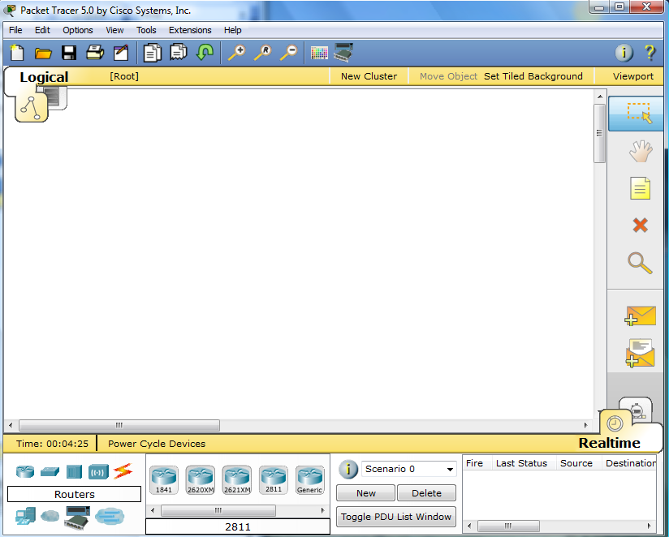

**Step 2: Choosing Devices and Connections**

We will begin building our network topology by selecting devices and the media in which to connect them. Several types of devices and network connections can be used. For this lab we will keep it simple by using **End Devices**, **Switches**, **Hubs**, and **Connections**.

Single click on each group of devices and connections to display the various choices. The devices you see may differ slightly.

|  |  |
| --- | --- |
|  |  |
|  |  |
|  | |
|  |  |
|  |  |

**Step 3: Building the Topology – Adding Hosts**

Single click on the **End Devices**.

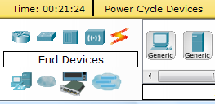

Single click on the **Generic** host.



Move the cursor into topology area. You will notice it turns into a plus “+” sign.

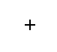

Single click in the topology area and it copies the device.

|  |  |
| --- | --- |
|  |  |

Add three more hosts.

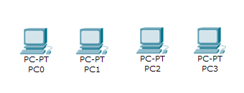

**Step 4: Building the Topology – Connecting the Hosts to Hubs and Switches**

**Adding a Hub**

Select a hub, by clicking once on **Hubs** and once on a **Generic** hub.

|  |  |  |
| --- | --- | --- |
|  |  |  |

Add the hub by moving the plus sign “**+**” below PC0 and PC1 and click once.

|  |  |
| --- | --- |
|  |  |

Connect PC0 to Hub0 by first choosing **Connections.**

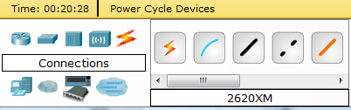

Click once on the **Copper Straight-through** cable.

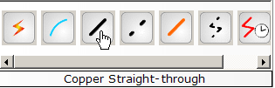

Perform the following steps to connect **PC0** to **Hub0**:

1. Click once on **PC0**
2. Choose **FastEthernet**
3. Drag the cursor to **Hub0**
4. Click once on **Hub0** and choose **Port 0**
5. Notice the green link lights on both the **PC0** Ethernet NIC and the **Hub0** Port 0 showing that the link is active.

|  |  |  |  |  |
| --- | --- | --- | --- | --- |
| **1** | **2** | **3** | **4** | **5** |
|  |  |  |  |  |

Repeat the steps above for **PC1** connecting it to **Port 1** on **Hub0**. (The actual hub port you choose does not matter.)

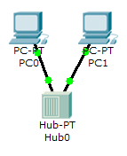

**Adding a Switch**

Select a switch, by clicking once on **Switches** and once on a **2950-24** switch.

|  |  |  |
| --- | --- | --- |
|  |  |  |

Add the switch by moving the plus sign “**+**” below PC2 and PC3 and click once.

|  |  |
| --- | --- |
|  |  |

Connect PC2 to Hub0 by first choosing **Connections.**



Click once on the **Copper Straight-through** cable.



Perform the following steps to connect **PC2** to **Switch0**:

1. Click once on **PC2**
2. Choose **FastEthernet**
3. Drag the cursor to **Switch0**
4. Click once on **Switch0** and choose **FastEthernet0/1**
5. Notice the green link lights on **PC2** Ethernet NIC and amber light **Switch0** **FastEthernet0/1 port**. The switch port is temporarily not forwarding frames, while it goes through the stages for the Spanning Tree Protocol (STP) process.
6. After a about 30 seconds the amber light will change to green indicating that the port has entered the forwarding stage. Frames can now forwarded out the switch port.

Note: Spanning Tree Protocol (STP) is discussed later.

|  |  |  |  |  |  |
| --- | --- | --- | --- | --- | --- |
| **1** | **2** | **3** | **4** | **5** | **6** |
|  |  |  |  |  |  |

Repeat the steps above for **PC3** connecting it to **Port 3** on **Switch0** on port **FastEtherent0/2**. (The actual switch port you choose does not matter.)

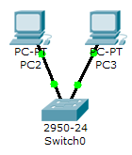

Move the cursor over the link light to view the port number. **Fa** means FastEthernet, 100 Mbps Ethernet.

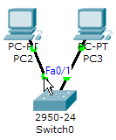

**Step 5: Configuring IP Addresses and Subnet Masks on the Hosts**

Before we can communicate between the hosts we need to configure IP Addresses and Subnet Masks on the devices.

Click once on PC0.

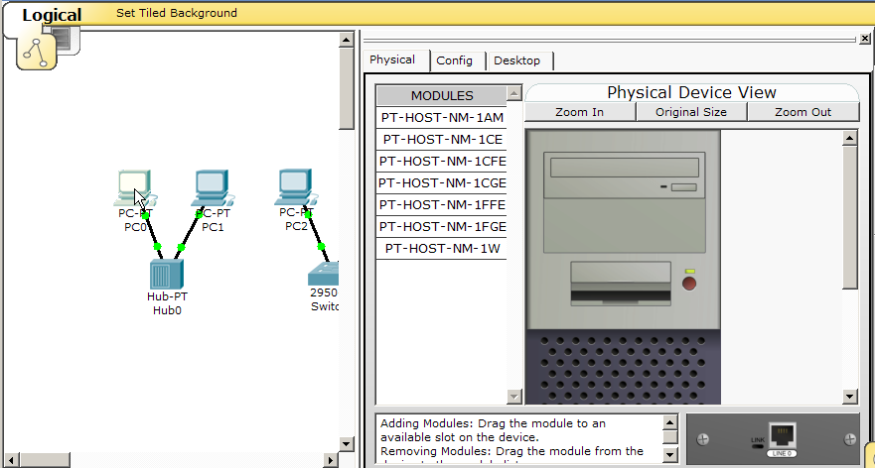

Choose the **Config** tab and click on **Settings**. It is here that you can change the name of PC0. It is also here where you would enter a **Gateway** IP Address, also known as the default gateway and the **DNS Server** IP Address. We will discuss this later, but this would be the IP address of the local router. If you want, you can enter the Gateway IP Address 172.16.1.1 and DNS Server IP Address 172.16.1.100, although it will not be used in this lab.

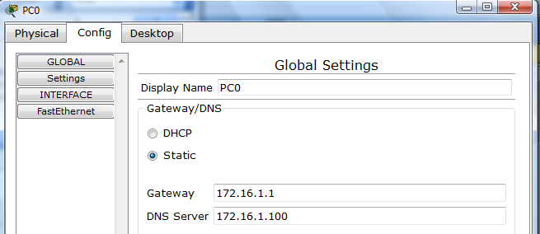

Click on **Interface** and then **FastEthernet**. Although we have not yet discussed IP Addresses, add the IP Address to 172.16.1.10. Click once in the Subnet Mask field to enter the default Subnet Mask. You can leave this at 255.255.0.0. We will discuss this later.

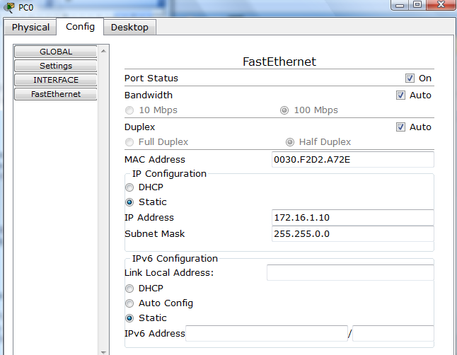

Also, notice this is where you can change the Bandwidth (speed) and Duplex of the Ethernet NIC (Network Interface Card). The default is Auto (autonegotiation), which means the NIC will negotiate with the hub or switch. The bandwidth and/or duplex can be manually set by removing the check from the **Auto** box and choosing the specific option.

**Bandwidth - Auto**

If the host is connected to a hub or switch port which can do 100 Mbps, then the Ethernet NIC on the host will choose 100 Mbps (Fast Ethernet). Otherwise, if the hub or switch port can only do 10 Mbps, then the Ethernet NIC on the host will choose 10 Mbps (Ethernet).

**Duplex - Auto**

**Hub**: If the host is connected to a hub, then the Ethernet NIC on the host will choose Half Duplex.

**Switch**: If the host is connected to a switch, and the switch port is configured as Full Duplex (or Autonegotiation), then the Ethernet NIC on the host will choose Full Duplex. If the switch port is configured as Half Duplex, then the Ethernet NIC on the host will choose Half Duplex. (Full Duplex is a much more efficient option.)

The information is automatically saved when entered.

To close this dialog box, click the “**X**” in the upper right.



Repeat these steps for the other hosts. Use the information below for IP Addresses and Subnet Masks.

|  |  |  |
| --- | --- | --- |
| **Host** | **IP Address** | **Subnet Mask** |
| PC0 | 172.16.1.10 | 255.255.0.0 |
| PC1 | 172.16.1.11 | 255.255.0.0 |
| PC2 | 172.16.1.12 | 255.255.0.0 |
| PC3 | 172.16.1.13 | 255.255.0.0 |

**Verify the information**

To verify the information that you entered, move the Select tool (arrow) over each host.

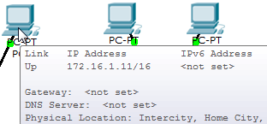

**Deleting a Device or Link**

To delete a device or link, choose the **Delete** tool and click on the item you wish to delete.

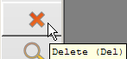

**Step 6: Connecting Hub0 to Switch0**

To connect like-devices, like a Hub and a Switch, we will use a Cross-over cable. Click once the **Cross-over** Cable from the **Connections** options.

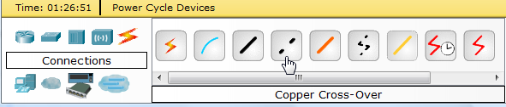

Move the Connections cursor over **Hub0** and click once.

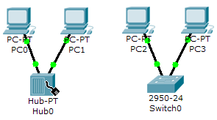

Select **Port 5** (actual port does not matter).

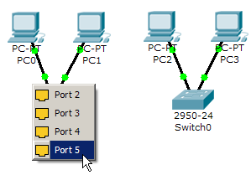

Move the Connections cursor to **Switch0**.

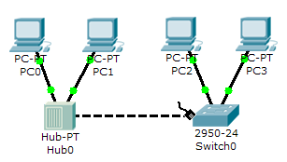

Click once on **Switch0** and choose **FastEthernet0/4** (actual port does not matter).

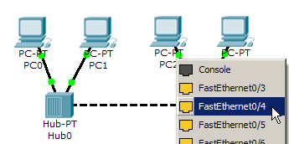

The link light for switch port **FastEthernet0/4** will begin as amber and eventually change to green as the Spanning Tree Protocol transitions the port to forwarding.

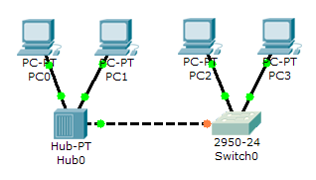

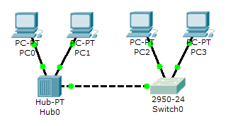

**Step 7: Verifying Connectivity in Realtime Mode**

Be sure you are in **Realtime** mode.

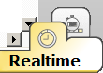

Select the **Add Simple PDU** tool used to ping devices..



Click once on PC0, then once on PC3.

|  |  |
| --- | --- |
|  |  |

The PDU **Last Status** should show as **Successful**.

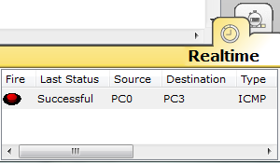

**Resetting the Network**

At this point we will want to reset the network, whenever you want to reset the network and begin the simulation again, perform the following tasks:

Click **Delete** in the PDU area.

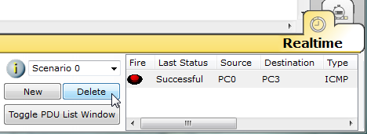

Now, Power Cycle Devices and confirm the action.

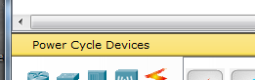

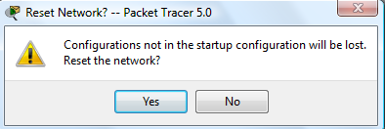

**Waiting for Spanning Tree Protocol (STP)**

**Note**: Because Packet Tracer also simulates the Spanning Tree Protocol (later), at times the switch may show amber lights on its interfaces. You will need to wait for the lights to turn green on the switches before they will forward any Ethernet frames.

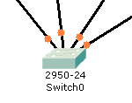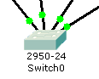

**Step 8: Verifying Connectivity in Simulation Mode**

Be sure you are in **Simulation** mode.

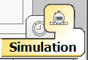

Deselect all filters (All/None) and select only **ICMP**.

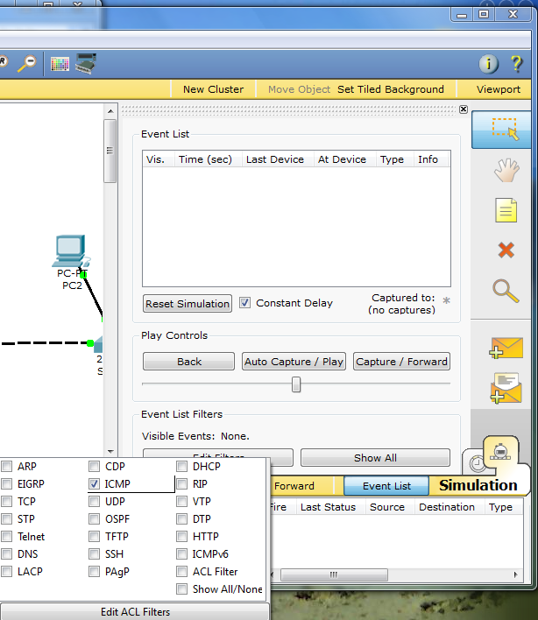

**3**

**2**

**1**

Select the **Add Simple PDU** tool used to ping devices..



Click once on PC0, then once on PC3.

|  |  |
| --- | --- |
|  |  |

Continue clicking **Capture/Forward** button until the ICMP ping is completed. You should see the ICMP messages move between the hosts, hub and switch. The PDU **Last Status** should show as **Successful**. Click on **Clear Event List** if you do not want to look at the events or click **Preview Previous Events** if you do. For this exercise it does not matter.

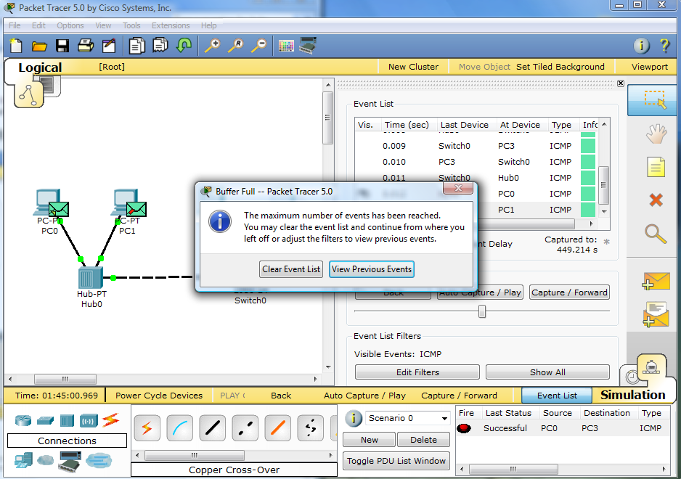

**Step 9: Saving the Topology**

Perform the following steps to save the topology (uses .pkt file extension).

|  |  |
| --- | --- |
|  |  |

**Opening Existing Topologies**

|  |  |  |
| --- | --- | --- |
|  |  |  |

**Opening Existing PT Topologies**

|  |  |  |
| --- | --- | --- |
|  |  |  |
|  |  |  |

**Lab Work:**

**Task 1: Simulate a Virtual Network with an Ethernet Hub**

1. Create network topology in the packet tracer like this one:



This scenario consists of a LAN with a server and two workstations connected by an Ethernet Hub.

1. In the Packet Tracer window, change from Real-time mode to Simulation mode.
   * + - 1. In the lower-right corner you will see the following:



This shows that the current mode is “Realtime” – traffic flows without any pause or slowing.

* + - * 1. Click the “stop watch” icon behind the Realtime icon:



You are now in Simulation mode – traffic will flow but each packet will be sent individually and in slow motion. This will allow us to watch the traffic on the LAN.

1. In simulation mode, we can control the “types” of traffic we see in Packet Tracer. For this lab, we only want to see ping packets (test messages to check connectivity).
   * + - 1. In the Edit Filter dialog box, clear the check mark next to **Show All/None**. All the check marks should disappear.
         2. Still in the Edit Filter dialog, enable the ICMP protocol by putting a check mark in its box.
         3. Click anywhere outside of the Edit Filter dialog to make this dialog disappear. Your Event List Filter should look like that shown in this figure:



1. We will now create a simple test message inside of Packet Tracer. Click on the icon that looks like a closed envelope (the “open envelope” creates a complex message which is more than we want right now).



1. Now click first on PC0 (in the main packet tracer pane) then click on Server1. This action specified the source and destination of our test packet. An icon of an envelope will appear next to PC0; it is “ready” to send.
2. In the main Packet Tracer window, click the button for “Capture / Forward” *one time only*.



Which devices did the current packet move from and to?

From: -------------------------------------------------------------------

To: ----------------------------------------------------------------------

1. Click the “Capture / Forward” button a second time. Where did the packet move from and to?

From: -------------------------------------------------------------------

To: -----------------------------------------------------------------------

1. Click on the packet that has arrived at PC1, In the packet details, click “Layer 2” under the “In-Layers” to see what happens at the Data-link layer (layer-2) on PC1. If we realize that the MAC address is the Layer-2 address, what does PC1 do with this packet when it is received and why?

------------------------------------------------------------------------------------------------------------------

------------------------------------------------------------------------------------------------------------------

------------------------------------------------------------------------------------------------------------------

------------------------------------------------------------------------------------------------------------------

1. Repeat step 10 for the packet received by Server1. Look at what happens as the packet comes into Layer 2, moves up to layer 3, and then is sent out of layer 3 and through layer 2, follow the actions taken by Server1 at the various in-coming and out-going layers for this packet. What does it do and why (try to use your own words to describe what happens)?

Layer 2 under In Layers:

------------------------------------------------------------------------------------------------------------------

------------------------------------------------------------------------------------------------------------------

Layer 3 under In Layers:

------------------------------------------------------------------------------------------------------------------

------------------------------------------------------------------------------------------------------------------

Layer 3 under Out Layers:

------------------------------------------------------------------------------------------------------------------

------------------------------------------------------------------------------------------------------------------

Layer 2 under Out Layers:

------------------------------------------------------------------------------------------------------------------

------------------------------------------------------------------------------------------------------------------

1. Play the rest of the simulation by clicking on the “Auto Capture/Play” button. What the Hub does every time it receives a packet.

------------------------------------------------------------------------------------------------------------------

------------------------------------------------------------------------------------------------------------------

1. Close Packet Tracer but don’t save your changes.

**Task 2: Simulate a Virtual Network with an Ethernet Switch**

* + - 1. Create network topology in the packet tracer like this one:



Here we have a LAN with a server and two workstations connected by an Ethernet ***Switch***.

* + - 1. Use the techniques you learned in the previous task to put Packet Tracer into simulation mode.
      2. To minimize what types of packets show up in our simulation, we will again create a filter. Use what you learned previously in this lab to configure Packet Tracer to show only ICMP packets (refer back if you need to).
      3. Use what you learned in the previous task to create a simple test message inside of Packet Tracer from PC2 to Server2. (Refer back to earlier in the lab if you can’t remember how to do this).
      4. Repeatedly use the “Capture / Forward” button and watch the packets as they move. You should watch the packets as they move both from and back to PC2.
      5. Briefly describe the path taken by a ping (ICMP) packet between PC2 and Server2 and back – that is, what devices does the packet go through. Be sure to include how much PC3 is involved in this communication. What did this happen this way?

------------------------------------------------------------------------------------------------------------------

------------------------------------------------------------------------------------------------------------------

------------------------------------------------------------------------------------------------------------------

------------------------------------------------------------------------------------------------------------------

------------------------------------------------------------------------------------------------------------------

------------------------------------------------------------------------------------------------------------------

* + - 1. What effect would using a switch instead of a hub have in an environment with a large number of workstations?

------------------------------------------------------------------------------------------------------------------

------------------------------------------------------------------------------------------------------------------

* + - 1. Leave the packet tracer program running with the C1Lab03-Switch simulation running.

**Task 3: Examine Broadcast communication**

* + - 1. At the bottom of the Packet Tracer window, click the “Delete” button. This will delete any packets remaining to be processed from the last scenario.



* + - 1. Click on the icon that looks like an open envelope to add a complex packet.



* + - 1. Click on PC2 to specify the source of our complex packet. A Create Complex PDU dialog box will open.
      2. In the field for the Destination IP Address, enter **255.255.255.255**. This is the broadcast IP address.
         1. In the Sequence Number field, enter a value of 1.
         2. In the Time field, enter a value of 1.
         3. Click the Create PDU button to create the packet at PC2. (You may need to click Capture / Forward once to see the packet.)
      3. Click the “Capture / Forward” button one time.
      4. Click on the packet that has arrived at the switch. What does the Switch find in the destination address at Layer-2 of the packet it received?

------------------------------------------------------------------------------------------------------------------

------------------------------------------------------------------------------------------------------------------

* + - 1. Under the Out-layers of the frame details, what will the switch do with the packet it received at Layer-2?

------------------------------------------------------------------------------------------------------------------

------------------------------------------------------------------------------------------------------------------

* + - 1. Close the details windows for the packet at the Switch.
      2. Click the “Capture / Forward” button one time.
      3. Where did the packet(s) move to?

------------------------------------------------------------------------------------------------------------------

------------------------------------------------------------------------------------------------------------------

* + - 1. What will Server 2 do with the packet it received? What will PC3 do with the packet it received? If necessary, look at the details of the packets received by each of the machines.

------------------------------------------------------------------------------------------------------------------

------------------------------------------------------------------------------------------------------------------

------------------------------------------------------------------------------------------------------------------

------------------------------------------------------------------------------------------------------------------

* + - 1. Continue clicking the “Capture / Forward” button to check yourself.